09/2014

Diskussionspapier

Thorsten Schulten Reinhard Bispinck
191

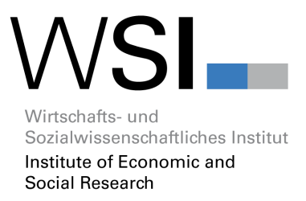

Wages, Collective Bargaining and Economic Development in Germany
Towards a more expansive and solidaristic development?

Abstract

During the last decades, German industrial relations has un- dergone some significant changes leading to a partial erosion and fragmentation of collective bargaining as well – and more fundamentally – to a significant change in power relations and the weakening of trade unions. As a result of this, wage devel- opments in the 2000s in Germany became rather moderate with a growing differentiation among sectors, a sharply rising incidence of low wages and an overall decline of the wage share. This moderate wage development also influenced Ger- many’s overall economic development model as it significantly dampened private demand and thereby promoted a growing discrepancy between a flourishing export industry and a large- ly stagnating domestic sector. More recently, there have been some indications that German wage policy might change again in a somewhat more expansive and solidaristic direction.

www.wsi.de

In der Reihe „WSI-Diskussionspapiere“ erscheinen in unregelmäßiger Folge Arbeiten aus dem WSI zu aktuellen Vorgängen auf wirtschafts-, sozial- und gesellschaftspolitischem Gebiet. Sie basieren u. a. auf Vorträgen, die Mitglieder des Instituts gehalten haben oder auf gutachterli- chen Stellungnahmen, können aber auch Diskussionsbeiträge zu ausgesuchten Einzelthemen sein. Für den Inhalt sind die Autorinnen und Autoren selbst verantwortlich.
Dieses und andere WSI-Diskussionspapiere finden Sie als pdf-Datei unter: www.wsi.de

Gedruckte Einzelexemplare sind zu beziehen über: Wirtschafts- und Sozialwissenschaftliches Institut in der Hans-Böckler-Stiftung (WSI i.d. HBS), Hans-Böckler-Straße 39, 40476 Düsseldorf

Dr. Thorsten Schulten Dr. Reinhard Bispinck
WSI in der Hans-Böckler-Stiftung Hans-Böckler-Straße 39
40476 Düsseldorf
thorsten-schulten@boeckler.de reinhard-bispinck@boeckler.de

WSI-Diskussionspapiere (Print) ISSN 1861-0625
WSI-Diskussionspapiere (Internet) ISSN 1861-0633

Inhalt
- Introduction 1
- Collective bargaining: partial erosion 2
- Collective bargaining: decentralisation and fragmentation 4
- Changes in power relations and the role of trade unions 6
- Wage developments 9
  - Collectively agreed and actual wages 9
  - Growing differentiation 11
  - Increasing low-wage incidence 12
  - Development of the wage share 13
- Wages and economic development 14
- The future of wage policy in Germany 17
  - The introduction of a statutory minimum wage 17
  - Re-strengthening of collective bargaining 18
  - Towards a more expansive and solidaristic wage policy? 19
- References 20

1 Introduction
Until the 1990s, German capitalism was widely regarded as a successful synthesis of a highly competitive economy with high wage performance and relatively equal distribution of income (Streeck 1997). The economic backbone of the German political economy was a strong manufac- turing sector with specialisation on high quality production in branches such as automobiles, electronics, chemicals, engineering and machine building, which promoted an export-oriented development model. On the other hand, relatively strong trade unions and a rather comprehen- sive collective bargaining system ensured that the majority of German workers could participate in the overall economic development and the domestic sector did not lag too far behind the export industries. During the last decades, however, German capitalism has undergone some fundamental transformations which questioned the efficiency and equality achieved by the for- mer social contract (Streeck 2009). Faced by new external challenges following the 1990 German unification, European integration and growing internationalisation, Germany entered a period of neo-liberal restructuring of its traditional welfare state and labour market institutions. Among other things, this had a major impact on the development of wage policy in Germany leading to a partial erosion and fragmentation of collective bargaining as well – and more fundamentally – to a significant change in power relations and the weakening of trade unions. As a result of this, wage developments in the 2000s in Germany became extremely moderate with a growing dif- ferentiation among sectors, a sharply rising incidence of low wages and an overall decline of the wage share.
This moderate wage development also influenced Germany’s overall economic development model as it significantly dampened private demand and thereby promoted a growing discrepan- cy between a flourishing export industry and a largely stagnating domestic sector. As Germa- ny’s economic development became increasingly export-led, it not only failed to exhaust its domestic growth potential but it also promoted growing economic imbalance between countries within Europe as well as at a global level. The deep international economic crisis in 2009 and the following economic turbulences in Europe showed that economic development models, mainly dependent on export industries, were far from sustainable. A more balanced economic devel- opment plainly requires a much higher degree of income equality as well as strong institutions and actors which are able to promote a more equal development.
More recently, there have been some indications that German wage policy might change again in a somewhat more expansive and solidaristic direction. These tendencies have been support- ed by a more favourable situation in the labour market as well as by trade unions which have at least regained some political strength and influence. The introduction of a national minimum wage and the strengthening of collective bargaining through a reform of extension procedures are notable here in that both have strong potential to push German wage policy in a new direc- tion.

Collective bargaining: partial erosion
In the 1950s Germany developed a comprehensive system of multi-employer bargaining at sec- toral level. Collective agreements between trade unions and employers’ associations covered almost all sectors of the Germany economy. For more than four decades, German collective bargaining covered between 80 and 90 per cent of all German workers. Against that back- ground, the state played only a minor role in the regulation of wages in Germany. Although there has always been the possibility for an extension of collective agreements, this instrument has been used only rarely and was always limited to a few domestic sectors such as construc- tion, retail and other services (Bispinck 2012). Moreover, Germany never had a statutory mini- mum wage, since the notion was seen as being in contradiction to the principle of ‘collective bargaining autonomy’ (Tarifautonomie). As a result, minimum wages in Germany were exclu- sively determined by collective agreements and affected only those workers covered by such agreements.
From the mid-1990s onwards, however, German collective bargaining entered a stage of pro- found change which led to the increasing fragmentation and partial erosion of collective bar- gaining (Bispinck and Schulten 2010; Haipeter 2013). The most obvious expression of these changes has been the continuous decline in bargaining coverage (see Figure 1). Between 1998 and 2013, the proportion of workers covered by collective agreements in West Germany de- creased from 76 per cent to 60 per cent. In East Germany, where after unification a full adoption of West German bargaining institutions never took place, bargaining coverage fell even further from 63 per cent to 47 per cent. For the whole of Germany, overall bargaining coverage in 2013 was estimated to be around 58 per cent (Ellgut and Kohaut 2014), although other sources had shown the somewhat lower coverage of only 55 per cent as early as 2010 (Statistisches Bun- desamt 2013).

Figure 1: Development of collective bargaining coverage, Germany, 1998-2013, in % of all employees

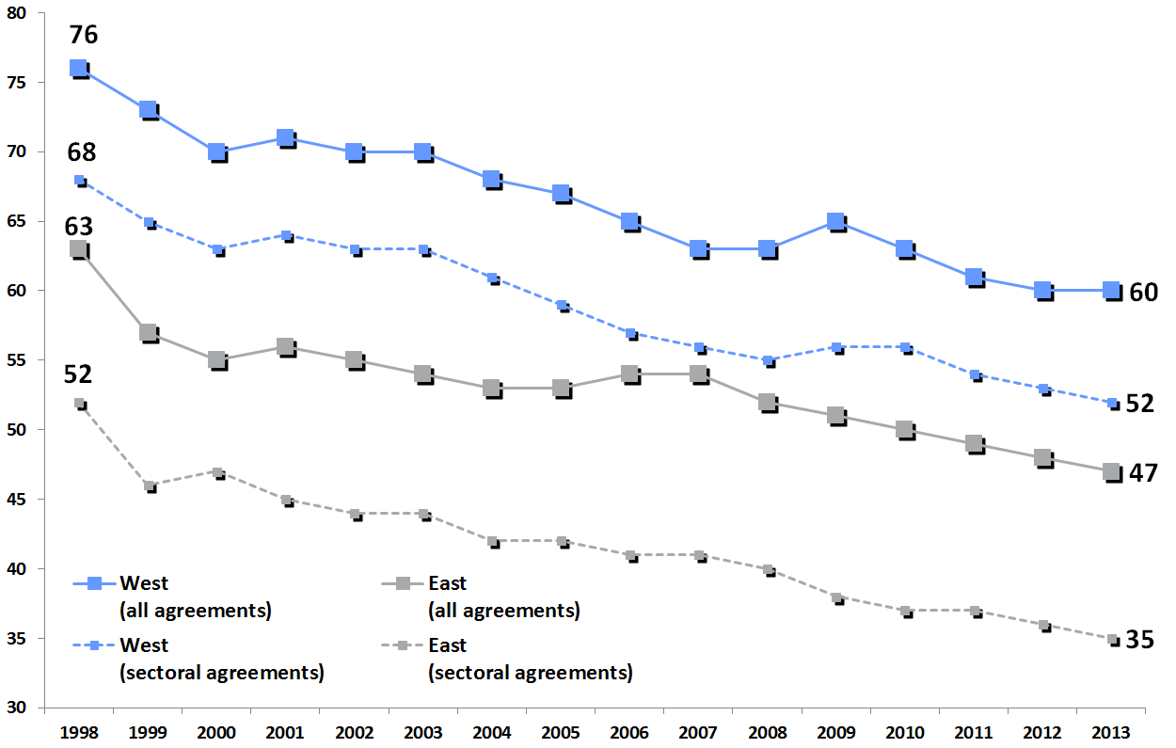

Source: IAB Establishment Panel

The partial erosion of German collective bargaining is even more obvious if we focus on the core of sectoral bargaining. Latest data show that in West Germany just over half of all workers (53 per cent) are covered by a sectoral agreement, while in East Germany only 36 per cent are covered. In addition to that, a further 7 per cent of West German and 12 per cent of East German workers are covered by company agreements signed by trade unions and individual employees. There has always been a significant number of companies not formally covered by an agree- ment but who nevertheless used existing agreements as an ’orientation’ for their own in-house wage-setting. However, more recently most of these companies have paid less than the collec- tively agreed wage standards (Addison et al. 2012).
Concerning collective bargaining coverage, there are also large differences across sectors (Fig- ure 2). In some such as public administration, education, financing, energy or postal services, a vast majority of workers (80 per cent and more) are still covered by collective agreements. The same holds true for some core manufacturing industries such as the automobile or chemical industries, where over two thirds of workers are still covered by agreements. Sectors such as construction, transport, health and social services and retail show a bargaining coverage be- tween 40 per cent and 50 per cent. Finally, in a large number of service sectors (e. g. hotels and restaurants, wholesale, scientific, technical and IT services, or automotive trade) only a minority of about one third of the workforce, or even less, is covered by collective agreements.

Figure 2: Collective bargaining coverage, Germany, 2010, in % of all employees

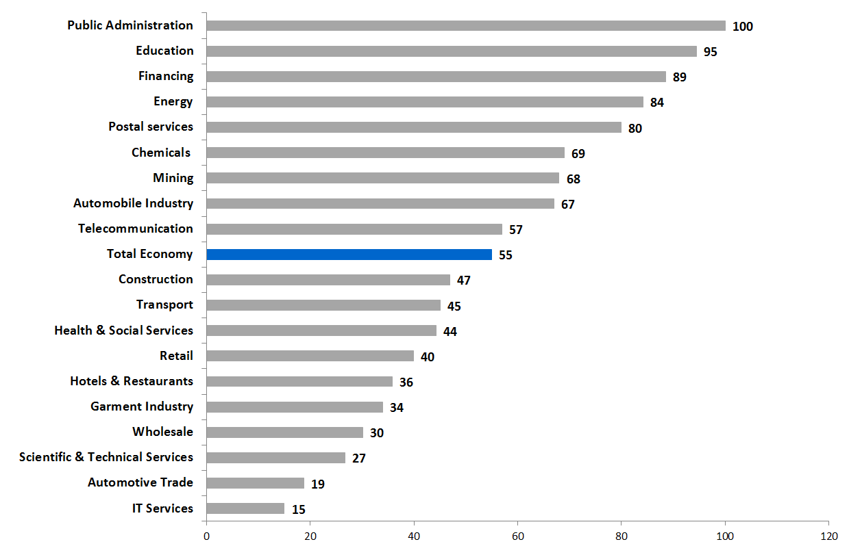

Source: Statistisches Bundesamt 2013

Finally, there is a close relationship between collective bargaining coverage and wage levels. Compared to other European countries, Germany has shown a rather unusual pattern whereby bargaining coverage increases with wage levels. Among the workers in the lowest wage 20 per cent (quintile) in 2010 only one third (33 per cent) were covered by an agreement; by contrast, bargaining coverage in the highest wage quintile was 66 per cent (source: WSI LohnSpiegel Database). Already, it can be seen that the partial erosion of German collective bargaining has been particularly marked in the low-wage sector where only a minority of workers were still covered by collective agreements. Moreover, in the German collective bargaining system sec- toral differentiation has been growing, with sectors in public services, utilities and some core manufacturing industries showing a rather high and relatively stable bargaining coverage. By contrast, many service sectors have faced a continuous decline of collective bargaining.

Collective bargaining: decentralisation and fragmentation
In addition to the partial erosion of the German bargaining system, it has also undergone a pro- cess of internal transformation best described as decentralisation and fragmentation (Bispinck and Schulten 2010, 2011a). From the mid-1990s onwards, the German system of sectoral collec- tive bargaining came under growing employer criticism for being ’too rigid’ and not allowing enough flexibility at company level. Originally, the demands for derogations from sectoral agreements came particularly from those companies in severe economic difficulties. Some of

these companies started to make in-house agreements, sometimes openly contravening valid collective agreements as they undermined collectively agreed standards. According to the so- called ’favourability principle’ laid down in the German Collective Bargaining Act (Tarifver- tragsgesetz), usually companies covered by sectoral agreement can only have company agree- ments that lead to the improvement of employment conditions not their deterioration. However, the Act also contains the possibility for trade unions and employers’ associations at sectoral level to agree so-called ‘opening clauses’ which, under certain conditions, allow companies to achieve temporary downward derogations.
Against the background of increasing unemployment in Germany, sectoral agreements from the mid-1990s increasingly included ’hardship clauses’ whereby companies got the possibility to undermine sectoral standards in exchange for the safeguarding of jobs. At first, such deviations were only possible under relatively strict conditions. However, over time the criteria for opening clauses were no longer restricted to the danger of bankruptcy but were widened to embrace all kind of situations and motivations including even the ’improvement of competitiveness’. By the mid-2000s almost all major industry-wide agreements included opening clauses which gave far- reaching opportunities for deviations at company level (Bispinck and Schulten 2011a). As a re- sult, concluding ’employment pacts’ at company level became a widespread activity leading to a broad wave of concession bargaining, especially in the manufacturing sector and in public utili- ties (Hassel 2014). On the workers’ side, major concessions were made in the:

  - extension of working time (with only partial or even no wage compensation);
  - reduction of working time and more flexible working time arrangements;
  - postponement of agreed wage increases;
  - reduction of special company payments above the collectively agreed rate;
  - reduction of collectively agreed bonus payments;
  - reduction of collectively agreed basic pay.

In exchange for the workers’ concessions the companies usually had to agree to make no com- pulsory redundancies for a certain period of time. In some cases the companies also agreed concrete funding or projects for new investment (Bispinck and Schulten 2011a).
Experience with this far-reaching process of decentralisation has been rather ambiguous. On the one hand, the deviations from sectoral agreements through employment pacts have proved to be a successful way to safeguard jobs, at least for the core workforce of the respective company. Furthermore, some unions have even used deviations to strengthen their role at shop floor level through their involvement in a more company-oriented bargaining policy (Haipeter 2009; Kocsis et al. 2013). On the other hand however, the decentralisation process has increasingly under- mined the effectiveness of sectoral collective agreements and their basic function namely to take wages and other working conditions out of competition. Moreover, most works councillors (the employee representatives at company level) have been rather sceptical regarding the trend towards decentralisation as it has led to a further power shift in favour of the company (Bispinck and Schulten 2011a). Quite often works councillors have felt ’blackmailed’ by their companies to accept concessions, and, as they could no longer refer to binding standards at sectoral level, have lost an important instrument of resistance. Finally, the decentralisation of collective bar- gaining has promoted a growing dualism in German labour relations, since it increases the divi-

sion between a relatively well protected ‘core’ workforce and much more precarious ‘peripheral’ groups of workers (Hassel 2014).
This dualism has become even more pronounced through a growing fragmentation of collective bargaining. The latter is the result of cost-oriented restructuring within companies and has at least four major implications for collective bargaining (Doellgast and Greer 2007; Flecker 2010). First, there is the strong trend towards outsourcing of (especially) service activities which usual- ly goes along with a shift from one bargaining area with higher wages to another with lower wages. Sometimes the outsourced activities even shift to companies not covered by any agree- ment at all. In such cases, outsourcing directly contributes to the decrease of bargaining cover- age. Second, many companies have reorganised their activities through the creation of numer- ous subsidiaries which were usually covered by different collective agreements. This particular form of ‘in-house outsourcing’ can be found both in manufacturing as well as in many services industries. It is widespread, for example, in the health care sector where hospitals, in particular, have created their own service companies in order to hire their service staff under conditions that differ from those of the hospitals core workforce. As a result, many different collective agreements came into being within one company leading to the creation of a two-tier workforce.
Third, the fragmentation of collective bargaining has been further pushed by the increasing use of temporary agency and contract work. Among others, it has been the German automobile industry who have been in the forefront of transforming regular jobs into non-standards types of employment. According to the Metalworkers Union IG Metall, in 2013 that industry had a core workforce of around 763,000 employees together with 100,000 temporary agency workers and 250,000 contract workers. This implies that over 30 per cent of automobile workers were no longer covered by the sectoral agreements of the metal industry (IG Metall 2013). Fourth, frag- mentation of collective bargaining, particularly in the public sector, has been promoted by a policy of privatisation and liberalisation. While privatisation usually involves withdrawal from the (formerly all encompassing) public sector agreements, liberalisation also often leads to the creation of a rather divergent bargaining landscape, whereby strong collective bargaining within the former incumbents or remaining public companies is pitted against the rather weak bargain- ing structures in the newly competing private companies. The latter process could be observed in sectors such as telecommunications, postal services, public transport or health and social services (Brandt and Schulten 2008; Schulten and Brandt 2012).

Changes in power relations and the role of trade unions
Above all, the changes in German collective bargaining can be interpreted as a shift in the pow- er relations between labour and capital leading to a significant loss of trade union power (Drib- busch and Birke 2012; Brinkmann and Nachtwey 2014). To some extent they also reflect more fundamental changes in the structural features and dominant politics of German capitalism (Streeck 2009). After a short-term unification boom in the early 1990s, Germany for more than a decade experienced a period of relatively weak overall economic development. Because eco- nomic growth was rather low in comparison to its neighbouring countries and unemployment

high, the country was even called ’the sick man of Europe’ (Dustmann et al. 2014). Unemploy- ment increased continuously until it peaked in the mid-2000s with over five million officially registered as unemployed which, according to the Eurostat definitions, gave an unemployment rate of 11.5 per cent. Under these conditions, German trade unions witnessed a significant shrinking of their structural power in the labour market and employers successfully used the threat of job losses to wrestle concessions from the workers’ side. The situation for the unions worsened as German politics increasingly endorsed policies of cutting social welfare and relax- ing employment protection. It was the social-democrat-led administration, in particular, that in the mid-2000s adopted the notorious ‘Hartz-Laws’, aimed at promoting a more comprehensive reorganisation of the German labour market (Knuth 2014). One major impact of these labour market reforms has been an acceleration of various forms of precarious employment which now counts for up to 40 per cent of the entire German workforce (Bispinck and Schulten 2011b).

Figure 3: Development of net trade union density, Germany, 1991-2011 (employed trade union members as % of all employees)

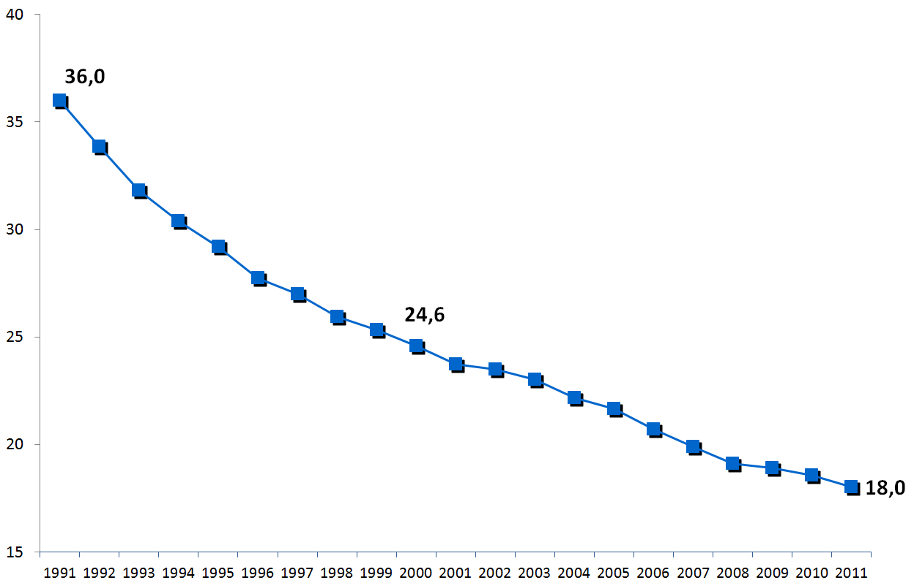

Source: Visser 2013

Finally, German unions also faced a significant loss of organisational power (Dribbusch and Birke 2012). Between 1991 and 2011, net union density was cut by half, from 36 per cent to 18 per cent (Figure 3). This fact not only reflected the changing economic framework conditions but also the political image and media discourse whereby unions were often pictured as old- fashioned and backward looking. According to a representative survey in 2003 only 23 per cent of the population had a ‘positive’ view on trade unions while for 45 per cent their image was clearly ‘negative’ (Figure 4).

Figure 4: Development of public image of trade unions, Germany, 2003-2012, as % of all persons surveyed

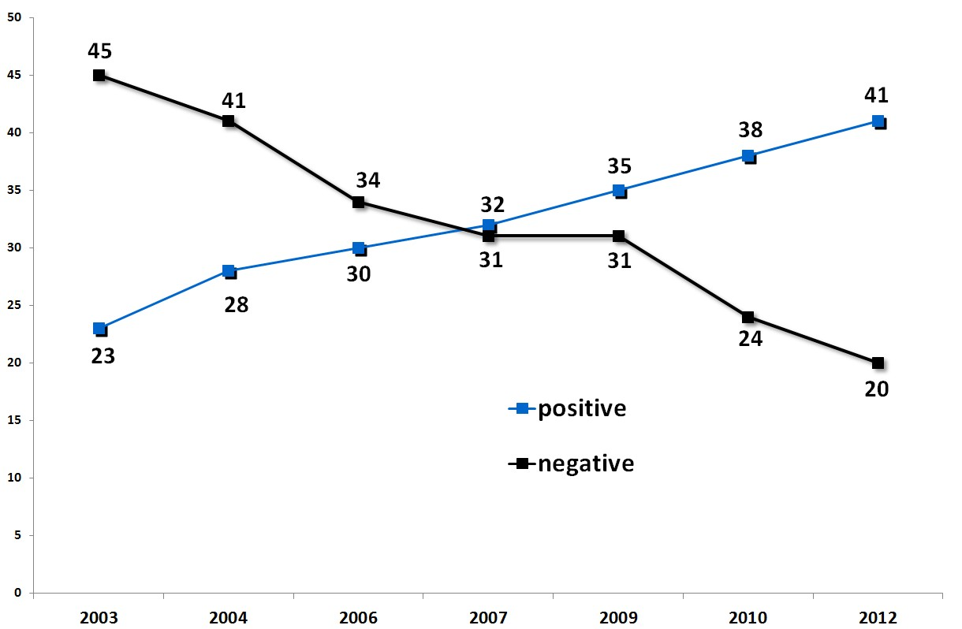
Source: Allensbach Institut für Demoskopie. Note: missing figures to 100% = undecided

The strong decline of unions’ structural and organisational power has also led to a significant weakening of their institutional power (cf. Arbeitskreis Strategic Unionism 2013), as the changes in the German collective bargaining systems prove. The high unemployment rate, in particular, prompted unions to accept a profound decentralisation of collective bargaining and the conclu- sion of numerous concession deals. Moreover, in many sectors, and especially in services, the
organisational power of unions became too weak to prevent employers from withdrawing from
1

collective bargaining.
Finally, the dominant policies in Germany for a long time were quite anti-

union and led to the growing incidence of precarious work, thus further weakening the unions’ structural power and indirectly contributing to the erosion of collective bargaining.
Since the late 2000s, however, the political and economic situation in Germany began to change and became somewhat more favourable for the unions. There were at least two major devel- opments behind this (Dribbusch and Birke 2014): First, the unions played a major role in tackling the economic crisis of 2009. Drawing on the traditional institutions of German industrial rela- tions, Germany saw the emergence of a new form of ‘crisis corporatism’ whereby the unions actively helped companies to survive and to maintain employment (Urban 2012). They did this not only by concluding innovative short-time work arrangements at company level, but also by successfully lobbying together with the employers for economic support from the state. As a

1
To a certain extent, the same applies to the German employers’ associations (Behrens 2011). In
order to prevent membership losses, they created a special form of membership whereby the companies were no longer bound by collective agreements (OT-Mitgliedschaft; OT = ohne Tarifbindung). As a result, the employers’ associations have contributed to, or even accelerated, the decline of collective bargaining coverage.

result, the unions became widely regarded as a successful crisis manager that helped Germany to overcome the crisis without major social disruptions. Second, there is a broad view in Ger- many that during the last decade the trend of growing inequality and precariousness had gone too far, bringing forward a need for some revisions in order to restore social justice. The unions were able to address these notions by calling for a ‘new order in the labour market’ (DGB 2013) and to organise successful campaigns against precarious employment (Bispinck and Schulten 2011b). It was the comprehensive campaign for the introduction of a statutory minimum wage, in particular, which gained widespread support among the German public and helped to restore the unions’ reputation as an important societal agent. Altogether, these developments contrib- uted to a ‘comeback’ of German trade unions (Schmalz and Dörre 2013) and led to a remarkable shift in their public image (Figure 4). While in 2003 only 23 per cent of the German population had appraised unions as ‘positive’, by 2012 this had grown to 41 per cent. During the same peri- od the proportion with a ‘negative’ assessment declined from 45 to 20 per cent.

Most recently the change in the public reputation of trade unions has also helped to halt the long-term trend of declining membership. In 2013, five out of eight DGB-affiliated unions (among them the two largest, IG Metall and Ver.di) noted a slight increase in membership (Drib- busch and Birke 2014). Although membership retention and recruitment to German unions has significantly improved, it is, however, still too early to talk about a real turnaround in union membership and it remains to be seen whether unions are able to stabilise this positive devel- opment.

Wage developments

Collectively agreed and actual wages

The fundamental shift in capital and labour power relations as well as the changes in the collec- tive bargaining system outlined above have had a major impact on the development of wages in Germany. Since the mid-1990s three main trends could be observed. First, average wages grew only very moderately and often below the rate of inflation, so that real wages went down. Se- cond, wage developments were increasingly differentiated across sectors. Third, and related to the second trend, the incidence of low wages rapidly increased. All in all, such wage develop- ments contributed to a strong increase of profits and a declining wage share, indicating a signif- icant income redistribution from labour to capital.
During the last decade, the development of collectively agreed wages has been extremely mod- erate. Adjusted for national consumer price developments, collectively agreed wages in the 12 years since 2000 have increased on average in real terms by only about 0.7 per cent (Figure 5). Taking the period between 2004 and 2008 in particular, agreed real wages were almost stagnant. The same holds true for the years 2001 and 2011, while in the other years the growth rates in real terms fluctuated between 0.7 and 1.4 per cent. Ironically, the highest increase of agreed real wages was in the crisis year 2009, due to an extremely low inflation rate. Comparing collectively agreed wage growth with actual wage growth (as calculated through the national accounts), German wage development has been characterised by a strong negative wage drift, implying

that, on average, actual wages grew much more slowly than agreed wages. With the exception of the recent years 2010 to 2012, for 12 years wage drift was negative. Moreover, between 2000 and 2009 actual wages showed a significant decrease even in real terms, returning to a positive development only from 2010 onwards. These figures show that German workers have been faced with a rather extraordinary development, namely that Germany in 2010 was the only country in the EU in which workers on average earned less in real terms than they did a decade earlier (Schulten 2011; European Commission 2014a).

Figure 5: Development of real collectively agreed and actual wages (deflated by CPI), annual change, Germany, 2000-2013

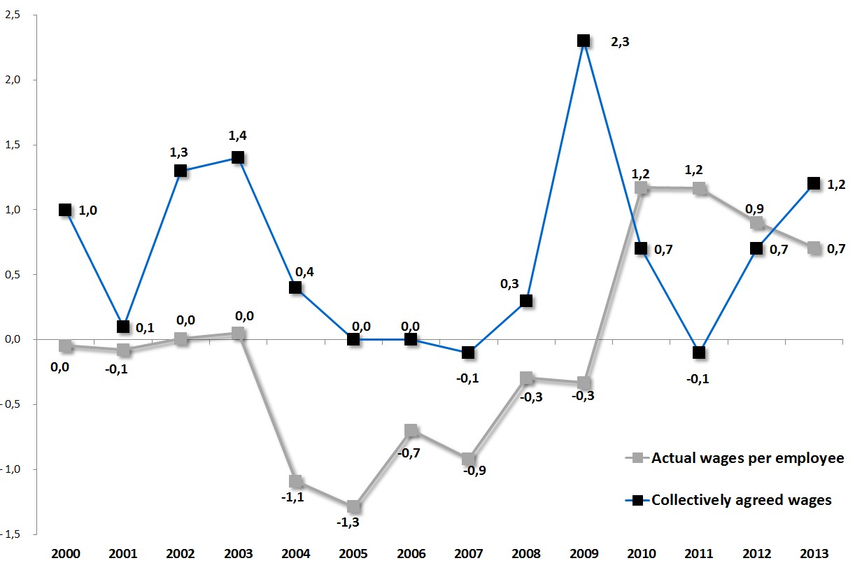
Sources: Destatis (Federal Statistical Office); WSI Collective Agreement Archive

The negative wage drift in Germany has pointed to some more fundamental problems of the country’s collective bargaining. It showed that on average German workers have only partially benefitted from the higher wage growth determined by collective agreements. Obviously, the decline of collective bargaining coverage is one reason for negative wage drift as wage increas- es in the non-covered sector were much lower. This holds true, in particular, for the non-covered workers in the low-wage sectors, where workers suffered the biggest decrease in real wages (see section 5.3). The decentralisation of collective bargaining has also contributed to the nega- tive wage drift, since a growing number of companies have sought to derogate from sectoral collective agreements by freezing or even (temporarily) cutting agreed wages. Finally, changes in working hours also influenced wage drift as a growing number of workers were employed part-time, contributing to the slower growth of the average wage per employee. The latter was particularly the case for the growing number of so-called ‘mini-jobbers’, performing low wage,

2
marginal part-time jobs usually not covered by collective agreement.
It is as yet unclear to what

extent the return of positive wage drift in the years 2010 to 2012 may represent a new trend. Normally in Germany actual wage developments react much faster to the business cycle than agreed wages, because collective agreements often have duration of two years or even longer. Therefore, a time lag between the development of agreed and actual wages may well explain the positive wage drift seen recently.

Growing differentiation

Before 2000, the German collective bargaining system was a typical example of a pattern bar- gaining system, whereby a major sector (usually the metal industry, sometimes also chemicals) acted as the trend setter for bargained wage increases in the economy at large. In this system, within a certain range, wage increases were similar for all sectors. Since the 2000s, however, the system of pattern setting has weakened, leading to a growing differentiation of wage develop- ments in particular between the manufacturing and services sectors (Figure.6). Between 2000 and 2013, the highest growth rates of collectively agreed wages could be found in metalworking and the chemical industry with around 40 per cent growth, while during the same period growth was only 30 per cent in the public sector and around 24 per cent in retail. In a growing number of service industries wages no longer followed the benchmarks set in manufacturing, but be- came more and more decoupled from overall wage trends.

2 ‘Mini-jobs’ are a special form of marginal employment whereby the worker can earn up to a maximum of (currently) 450 Euro per month without paying taxes or social security contribu- tions. Moreover, the employer only has to pay a lump sum of 30 per cent for taxes and social security. Since mini-jobbers have no limitations in terms of working time they often have long working hours and therefore earn low hourly wage rates. More than three quarters of all mini- jobbers are in low-wage employment (Kalina and Weinkopf 2014).

Figure 6: Development of collectively agreed wages, Germany, 2000- 2013, various sectors, 2000 = 100

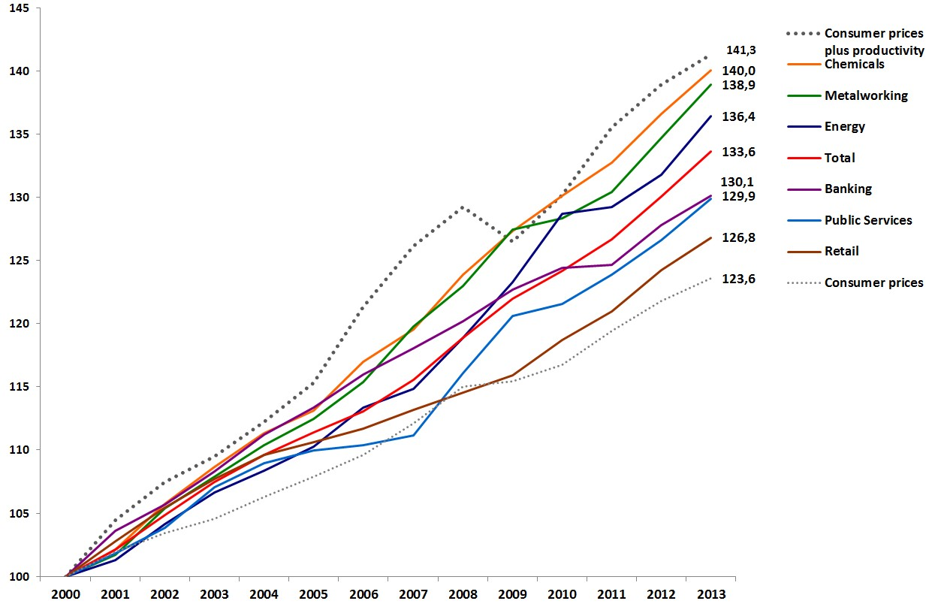
Source: WSI Collective Agreement Archive

Increasing low-wage incidence

The growing differentiation of wage developments between manufacturing and services indus- tries has also been closely linked to another feature of German wages, namely, growing wage and income inequality shown in particular by the strong increase in the incidence of low wages. In the 2000s, Germany’s Gini coefficient grew by 3.5 per cent points to reach 30.0 in 2008. With the exceptions of the UK and Italy, this was a rather high rate among Western European coun- tries. From the mid-1990s onwards, real wages of the lowest 15 per cent of the wage distribution fell dramatically, whilst wages at the top of the distribution continued to rise in real terms (Dustmann et al. 2014). Between 1995 and 2012 the percentage of low-wage workers, defined as those earning at or less than two-thirds of the median hourly wage, increased from 18.8 to 24.3 per cent (Figure 7). In absolute terms, the number of low-wage workers in Germany between 1995 and 2012 grew from 5.9 to 8.4 million, or by 48 per cent. Over-represented among low- wage earners were workers without vocational education (46.6 % low waged in 2012), females (30.8%), younger workers less than 25 years of age (56.7 %), migrant workers (34.5 %), and in particular those with mini-jobs (of which 78.6 % were low-waged in 2012) (Kalina and Weinkopf 2014). Today, Germany has one of the largest shares of low-wage workers across Europe (Schulten 2014). Large numbers of these workers could be found in service sectors such as ho- tels and restaurants, retail, security services, hairdressing etc. (Bosch and Kalina 2008; Amlinger et al. 2014).

Figure 7: Development of low wage incidence, Germany, 1995-2012

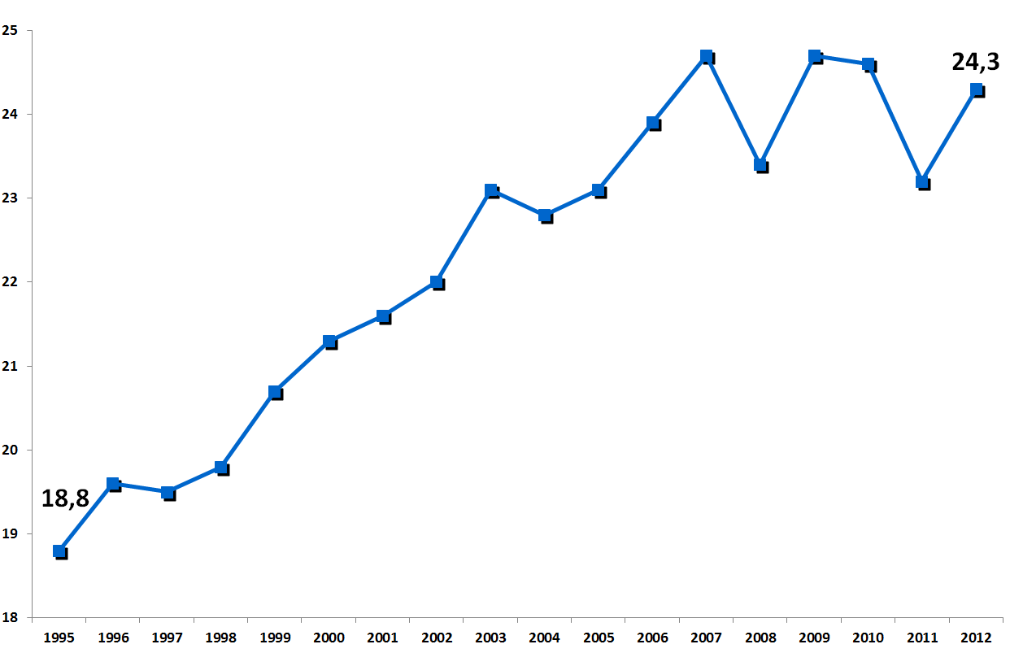
Source: Kalina and Weinkopf 2014

The strong increase in the incidence of low-wage workers has been closely related to the decline of collective bargaining coverage, evidenced, as already mentioned, by the fact that in 2010 only one third of the lowest wage quintile of wage-earners were covered by collective agreement. As Germany at that point had no SMW, more than two-thirds of German low-wage workers had to rely only on their individual bargaining position which was obviously not that strong. The low bargaining coverage among low-wage workers has emphasised that union density is extremely low in many service sectors. Since unions have not had the bargaining power to enforce higher wages, they often had either to accept rather low wage levels in collective agreements or to go without an agreement at all.

Development of the wage share

Considering the dominant trends in German wage developments outlined above, it is no sur- prise that the wage share saw a sharp decline during the 2000s. As Figure 8 indicates, between 2000 and 2007 the wage share dropped from 66.8 per cent to a historical low of 61.2 per cent. As in other EU member states, due to the sharp decrease in profits in the crisis years 2008 and 2009 it saw a temporary increase before showing a rather volatile picture. Technically speaking, the wage share will always decline if nominal wage growth is below the combined growth of con- sumer prices and productivity. Traditionally, German trade unions have regarded price and productivity growth as the ‘neutral margin of distribution’ (neutraler Verteilungsspielraum), setting the minimal requirement for wage increases in order to prevent a further decline of the wage share. The unions have often demanded a more expansive wage policy that aimed at re- distribution in favour of labour income. In practice however, except for a few years in the 1970s,

they were not able to enforce a more expansive wage policy. Moreover, since the 1980s the trend towards a decreasing wage share has only been temporarily interrupted and mostly in years of crisis. During the 2000s this trend accelerated due to extremely moderate wage devel- opments.

Figure 8: Development of adjusted wage share, total economy, Germany, 1970-2012

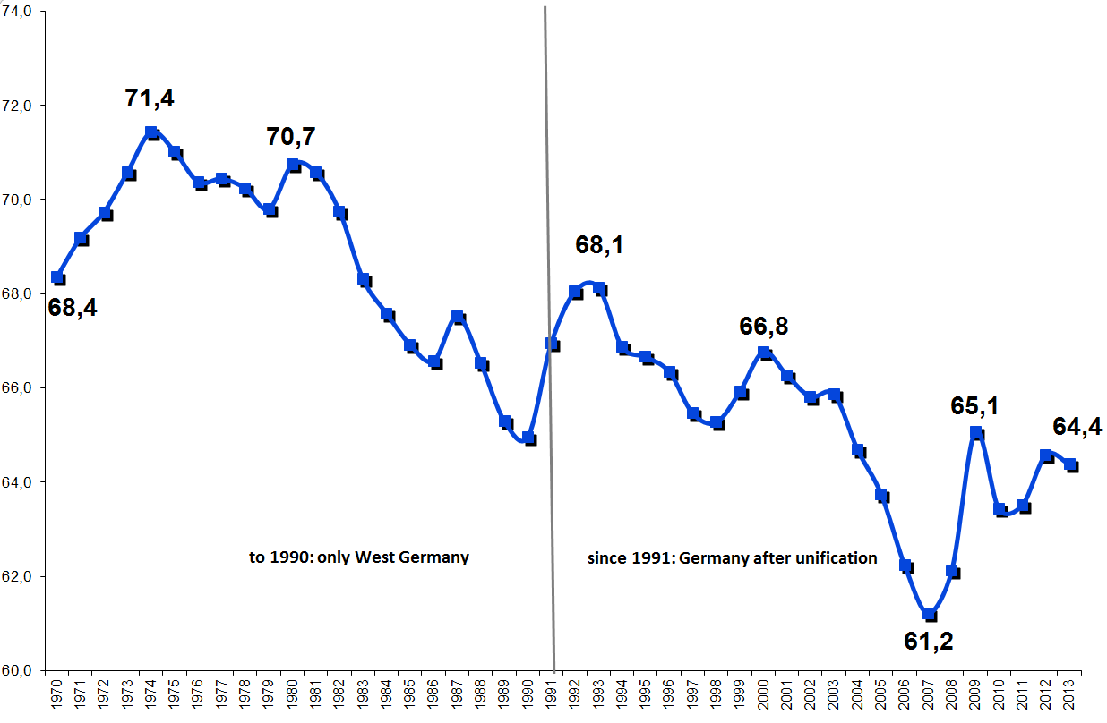
Source: AMECO Database of the European Commission. Note: Compensation per employee as percentage of GDP at factor cost per person employed

6 Wages and economic development
Traditionally, a relatively strong manufacturing sector that pursued export-oriented business strategies has been the backbone of Germany’s economic model. During the 1970s and 1980s export industries accounted for between 20 and 30 per cent of German GDP – already a rather high value for a large economy such as Germany. After decreasing somewhat in the 1990s due to the economic effects of German unification, the importance of the export sector increased sharply in the 2000s, growing to more than 50 per cent of the country’s GDP in the years 2011 to 2013 (all data: Statistisches Bundesamt 2014). Whilst Germany developed in absolute terms into ‘the world champion of exports’, it became ever more dependent on demand from abroad. Moreover, in the 2000s the German economy was increasingly characterized by the dualism of a flourishing export industry against an almost stagnant domestic demand (Joebges et al. 2009). As Figure 9 shows, German exports between 2000 and 2013 increased in real terms by over 90

per cent, while at the same time private consumption grew by only 9 per cent. Imports also grew significantly promoted, in particular, by intra-company trade and related imports of inter- mediate products, as many German manufacturing companies (re)organised their value chains both increasing investment in and subcontracting to other European countries. Yet, the weak development of domestic demand meant the growth of imports has not kept up with export growth, thus leading to an increasing export surplus.

Figure 9: Development of exports, imports and private consumption, Germany, 2000-2013, 2000 = 100

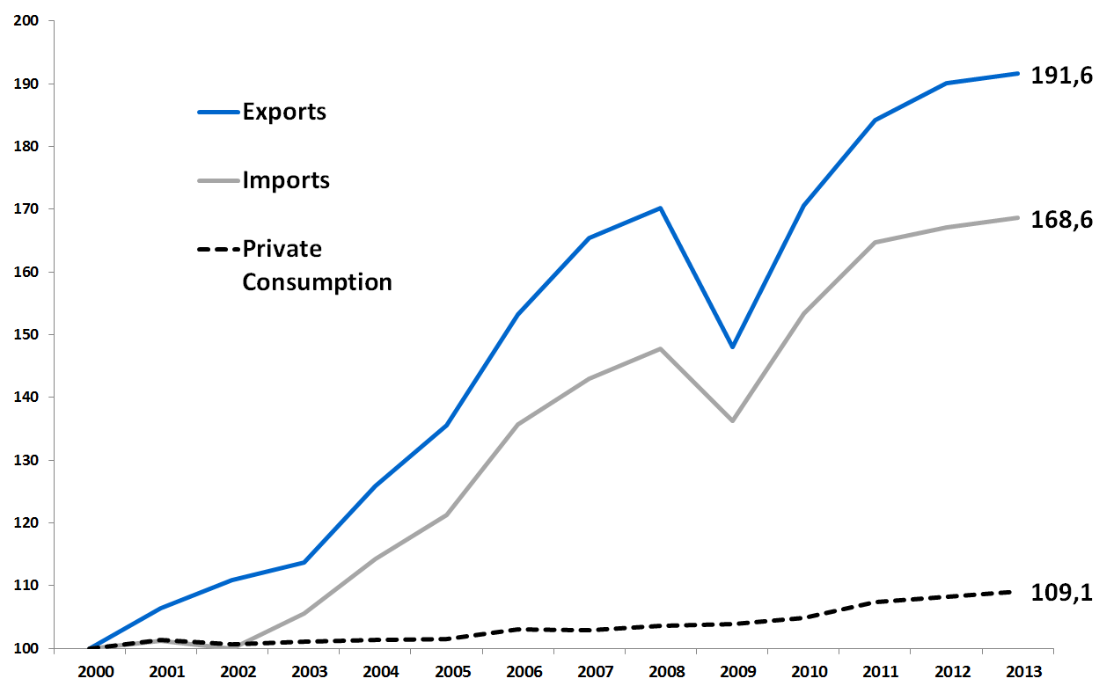
Source: Destatis, National Accounts

Germany’s one-sided export-led growth model has proved rather problematic in two respects. First, it has led to strong economic underperformance with negative effects for growth and em- ployment. Although the country obviously gained from its flourishing export industry which created and secured many well-paid jobs in manufacturing, weak domestic demand has under- mined the economy’s ability to realise its growth potential and, in consequence, it was not able to create sufficient jobs especially in labour-intensive services. The second, even more funda- mental problem with the German growth model, is that it has relied heavily on increasing export surpluses leaving other countries with corresponding deficits. In fact, in the 2000s Germany’s economic development has substantially contributed to growing macroeconomic imbalances both at the European and global levels, with strong negative economic consequences especially for the deficit countries (Joebges et al. 2009; Herzog-Stein et al. 2013a).
It is a widely held view that Germany’s export-led growth model has been largely promoted by the country’s very moderate wage developments. Basically, there are two channels through which wages have been influencing economic development, reflecting their double function as both a demand and a cost factor. The long-term decreases of median real wages and growing income inequality have obviously had a strong dampening effect on the development of internal

consumer demand. The same holds true for the comparatively weak development of imports into Germany. As a core factor of aggregate demand, German wage developments have clearly contributed to increasing international economic imbalances (cf. Sturn and van Treeck 2013). A number of observers have argued that the core reason for Germany’s strong export perfor- mance since the early 2000s can be found in the fact that German wages grew much more slow- ly than those in most other industrialised countries (e. g. Dustmann et al. 2014). From a more critical perspective, Germany has even been accused of following a strategy of ‘wage dumping’ whereby its economic success has only been achieved at the expense of other countries (e.g. Flassbeck and Lapavitsas 2013). The extremely moderate wage growth and the related devel- opment of unit labour costs have indeed led to a significant improvement of Germany’s price competitiveness. This has become even more important as Eurozone membership pre-empts the improvement of price competitiveness via a currency revaluation.
Competitiveness, however, is not just a matter of prices, but also of a range of other non-price factors such as producing innovative and specialised products, the quality of goods and ser- vices, the accuracy and engagement of business relations, et cetera. Taken into account the structure of the German export industry in some of its most developed sectors, such as machine building, chemicals or luxury cars production, labour costs have only played a minor role. In- deed, according to studies by the European Commission, the growth of the German export in- dustries could be explained only partly by the increase in price competitiveness. In addition to that, it was mainly the rapid development of demand in some of Germany’s main trading part- ners combined with a high non-price competitiveness of many German industries, which were the main factors behind Germany’s extraordinary export performance (European Commission 2014a; Kollmann et al. 2014). The fact that during the 2000s many Germany companies did not pass moderate wages onto lower prices but instead used wage moderation to increase their profits, is further proof of the relative importance of price competitiveness for the German ex- port industry (Herzog-Stein et al. 2013b). Finally, wages in the German manufacturing sector have clearly developed above the average of the German economy as a whole. Moreover, the manufacturing sector has paid relatively high wages to their core workforce compared to most foreign competitors. Thus, although this sector has profited from the fact that wages in other sectors in the German economy lagged behind, it cannot be concluded that its success in for- eign markets was mainly caused by low wages.
To sum up, there is a widespread myth about the ‘German model’, whereby its current relatively good economic performance has been perceived as a result mainly of Germany’s labour market reforms and changes to its collective bargaining system (Duval 2013, for an excellent decon- struction of that myth). The German economy has been highly dependent on its export industry, for which wage costs have been just one and not the core factor of competitiveness. The export- led growth model has, however, proved not at all sustainable as it has depended on strong in- ternational macroeconomic imbalances and may be highly vulnerable to future changes in the world economy. Moreover, extremely moderate wage developments and growing income ine- quality have also contributed to the strong underperformance of Germany’s domestic demand and thereby have promoted growing imbalances.

The future of wage policy in Germany
The current international perception of the German economic model is rather contradictory. On the one hand, in particular in Europe, it has been seen as a model to promote labour market reforms in other countries, drawing on the doubtful assumption that the latter were the key to Germany’s current economic success. On the other hand, there is a growing international awareness that in order to overcome macroeconomic imbalances not all countries could main- tain surpluses and also that surplus countries themselves need to reconsider their economic development strategy. The IMF, for example, has recently argued that “(…..) given the size of Germany’s economy and its large external imbalances, stronger and more balanced growth in Germany is critical to a lasting recovery in the euro area and global rebalancing” (IMF 2013, 2). Even the European Commission has recommended that “the policy priorities should be on strengthening domestic demand in Germany” (European Commission 2014b, 8). However, nei- ther the IMF nor the European Commission has yet made any recommendation for the future of Germany’s wage policy. This is astonishing insofar as there only two major ways to strengthen domestic demand. One is the increase of public investment, which has been comparatively low in Germany for a long time (Rietzler 2014). The other is, of course, the promotion of higher wage growth and a more equal income distribution in order to strengthen private consumption. A more expansive wage policy in Germany, however, requires first of all a restoration of wage regulation and collective bargaining.
Indeed, in July 2014 the German parliament adopted a new law on the ‘strengthening of collec- tive bargaining autonomy’ (Stärkung der Tarifautonomie) to become effective from the begin-
3

ning of 2015 (Bundesregierung 2014).
This new law could be seen as a major shift in German

labour market regulation away from the former neoliberal agenda of deregulation and flexibili- sation towards a strengthening of the position of the workers. The main elements in that law are the introduction of a statutory minimum wage (SMW) and stronger political support for sectoral collective bargaining through a reform of the extension mechanism.

The introduction of a statutory minimum wage

As long as Germany had a high bargaining coverage of 80 plus per cent, a national minimum wage was no topic at all. Even the German trade unions were for a long time opposed to statu- tory wage regulation, since they felt strong enough to ensure equitable wages through the con- clusion of collective agreements. The situation started to change around the millennium when some unions began to recognise a growing incidence of low wages especially in some private service sectors. It was the small Trade Union of Food, Beverages, Tobacco, Hotel and Catering Workers (NGG), which was the first German trade union to call for the introduction of a national minimum wage at their congress in 1999. Later on this demand was taken up by the much larger United Services Union (Ver.di). By contrast, the unions representing the manufacturing sector such as the German Metalworkers’ Union (IG Metall) and the Mining, Chemicals and Energy Industrial Union (IG BCE) were initially rather sceptical and considered a national minimum wage to be in contradiction to the principle of collective bargaining autonomy. After long and

3 For detailed analysis and comments on that law see Schulten and Bispinck 2014.

controversial debates among the unions, the Confederation of German Trade Unions (DGB) took a final decision at its congress in 2006, where a large majority voted in favour of a national stat- utory minimum wage.
The campaign for the introduction of a national minimum wage became one of the most suc- cessful trade union campaigns ever seen in Germany. The unions managed to gain support from large parts of the population and later from almost all major political parties, including the conservative Christian Democratic Party (CDU) whose leadership had opposed it to the last. After the general election in 2013 it was finally clear that a new ‘great coalition’ government of CDU and the Social Democratic Party (SPD) could only be formed if the CDU agreed on a na- tional minimum wage. Thus, in autumn 2013 the principle decision for the introduction of a national minimum wage was taken against the resistance of large parts of German employers and against the mainstream of German economists, who still mostly held the neoclassical view that a minimum wages would only lead to an increase of unemployment.
The new minimum wage law adopted in July 2014 foresaw the introduction of a SMW of 8.50 Euro per hour from 1 January 2015 (Bundesregierung 2014). It should be adjusted every two years based on the recommendation of a ‘Minimum Wage Commission’ composed of repre- sentatives of employers and trade unions. Under normal economic circumstances the develop- ment of the SMW should follow the average increase of collectively agreed wages. The SMW will be available for all employees with a few exceptions such as young workers below 18 or the long-term unemployed. For a transitional period of two years there will also be the possibility to pay below the national minimum wage of 8.50 Euro if a lower wage rate has been agreed by a nation-wide collective agreement. All in all, the national minimum wage will have a direct effect on the wages of up to five million employees (Amlinger et al. 2014).

Re-strengthening of collective bargaining

The unions’ campaign for the introduction of a SMW was from the beginning accompanied by demands for a strengthening of collective bargaining. From a union perspectives there are in principle two ways to secure a high bargaining coverage. Either the unions have the organisa- tional power to force employers to conclude collective agreements or there are (direct or indi- rect) forms of state support whereby collective agreements become generally applicable. With the exception of Denmark and Sweden all other European countries with a high bargaining cov- erage of 80 plus per cent have made extensive use of the extension of collective agreements or other forms of state support (Schulten 2012).
In Germany, there are two legal possibilities to extend collective agreements (Schulten and Bispinck 2013). The first is based on the German Collective Bargaining Act (Tarifvertragsgesetz) which allows extension only if already 50 per cent of the workers in a certain sector are already covered by a collective agreement. Since the 1990s the number of collective agreements which were extended on this legal basis has shown a steady decline and currently counts only for 1.5 per cent of all main agreements (Bispinck 2012). The second possibility to extend collective agreements is based on the German Posted Workers Act (Arbeitnehmer-Entsendegesetz). It has the advantage that in comparison to the first possibility it does not rely on a certain minimum threshold for a necessary bargaining coverage. However, extension on the basis of the Posted Workers Act also had at least to major disadvantages. First, it has so far been restricted to a

certain limited number of sectors. Currently, there are about 13 sectors covering mainly con- struction, construction related trades, industrial cleaning, security and care services. Secondly, the extension has some limitations regarding the content of the agreements. While extension on the basis of the Collective Bargaining Act can cover the whole wage table, extension on the basis of the Posted Workers Act usually covers only sectoral minimum wages.
The newly adopted law on the ‘strengthening of collective bargaining autonomy’ included re- forms on both legal procedures in order to facilitate the possibilities of extension (Bundesre- gierung 2014). Regarding the Collective Bargaining Act, the strict threshold for extension of 50 per cent bargaining coverage has been abolished and replaced by a vaguer criteria of a ‘pre- dominant meaning’ of the agreement which gives the state much more flexibility to extend an agreement even if the coverage is below 50 per cent. Furthermore, the state also gains much greater freedom to declare an agreement generally binding if there is a ‘public interest’. Regard- ing the Posted Workers Act the new law abolished all sectoral restrictions, so that in future all sectors will have the possibility to agree on sector-specific minimum wages on the basis of ex- tended collective agreements.

Towards a more expansive and solidaristic wage policy?

The most recent changes in the German system of wage-setting have a strong potential to pro- mote a more expansive and more solidaristic wage policy. The introduction of a national mini- mum wage will not only reduce the level of wage inequality by setting a universal wage floor. It will also strengthening the bargaining position of those at the bottom of the wage scale and thereby will positively influence the overall wage dynamic. In addition to that, the reform of extension procedures could help to restore collective bargaining and reverse the trend of declin- ing bargaining coverage. However, none of these effects will come ‘automatically’ but will de- pend on strong actors who are able and willing to use these new wage institutions. It will de- pend notably on the trade unions and their ability to further strengthen their different power resources. This holds true for their organisational power where unions still have to meet the challenge to transform their more positive public reputation into a higher degree of member- ship. It also holds true for their institutional power where the introduction of the national mini- mum wage is only a first step to establish a ‘new order at the labour market’ (DGB 2013) which further restrict different forms of precarious employment.
Finally, it is the structural power determined by the economic development in general and the situation at the labour market in particular which basically decide the strength and bargaining position of the trade unions. Therefore, the unions have a strong interest in shifting Germany’s one-sided export-oriented development into a more balanced development between export and domestic sectors. At this point the circle will be closed as a move towards a more sustainable economic development model in Germany requires – among other things – more expansive and more solidaristic wage developments.

References
Addison, J.T., Teixeira, P., Evers, K. and Bellmann, L. (2012) Is the Erosion Thesis Overblown? Evidence from the Orientation of Uncovered Employers. Bonn: IZA, Discussion Paper No. 6658.
Amlinger, M., Bispinck, R. and Schulten, T. (2014) “Niedriglohnsektor: Jeder Dritte ohne Min- destlohn? Ausnahmen vom geplanten Mindestlohn und ihre Konsequenzen.“ WSI-Report No. 12 (http://www.boeckler.de/wsi_5356.htm?produkt=HBS-005828&chunk=1&jahr=).
Arbeitskreis Strategic Unionism (2013) “Jenaer Machtressourcenansatz 2.0“, in S. Schmalz and
K. Dörre (eds), Comeback der Gewerkschaften? Machtressourcen, innovative Praktiken, internationale Perspektiven. Frankfurt a. M.: Campus, 345-75.
Behrens, M. (2011) Das Paradox der Arbeitgeberverbände. Berlin: Sigma.
Bispinck, R. (2012) “Allgemeinverbindlicherklärung von Tarifverträgen – vom Niedergang zur Reform?” WSI-Mitteilungen 65 (7): 496-507.
Bispinck, R. and Schulten, T. (eds) (2010) Zukunft der Tarifautonomie. 60 Jahre Tarifver- tragsgesetz: Bilanz und Ausblick. Hamburg: VSA.
Bispinck, R. and Schulten, T. (2011a) Sector-level bargaining and possibilities for deviations at company level: Germany. Dublin: European Foundation for the Improvement of Living and Working Conditions (http://www.eurofound.europa.eu/publications/htmlfiles/ef10874.htm).
Bispinck, R. and Schulten, T. (2011b) Trade Union Responses to Precarious Employment in Germany. Düsseldorf: WSI-Diskussionspapier No. 178 (http://www.boeckler.de/pdf/p_wsi_disp_178.pdf).
Bosch, G. and Kalina, T. (2008) “Low-wage work in Germany: An Overview”, in G. Bosch and C. Weinkopf (eds), Low-Wage Work in Germany. New York: Russell Sage Foundation, 19- 112.
Brandt, T. and Schulten, T. (2008) “Liberalisierung und Privatisierung öffentlicher Dienstleistun- gen und die Erosion des Flächentarifvertrags”. WSI-Mitteilungen 61(10): 570-576.
Brinkmann, U. and Nachtwey, O. (2013) “Industrial Relations, Trade Unions and Social Conflict in German Capitalism”. La Nouvelle Revue du Travail 2013-3 (http://nrt.revues.org/1382).
Bundesregierung (2014) “Gesetz zur Stärkung der Tarifautonomie (Tarifautonomiestärkungsge- setz), Deutscher Bundestag Drucksache 18/1558” (supplemented by Deutscher Bundestag Drucksache 18/2010 (neu)).
DGB (2013) Neue Ordnung der Arbeit. Berlin: DGB (http://www.dgb.de/themen/++co++002a7e1a- cdef-11e2-ab66-00188b4dc422).
Doellgast, V. and Greer, I. (2007) “Vertical disintegration and the disorganization of German industrial relations”. British Journal of Industrial Relations 45(1): 55-76.
Dribbusch, H. and Birke, P. (2012) Trade Unions in Germany. Organisation, Environment, Chal- lenges. Berlin: Friedrich Ebert Foundation (FES) (http://library.fes.de/pdf-files/id- moe/09113-20120828.pdf).
Dribbusch, H. and Birke, P. (2014) The DGB Trade Unions since the Crisis. Developments, Chal- lenges, Strategies. Berlin: Friedrich Ebert Foundation (FES) (http://library.fes.de/pdf- files/id-moe/10742.pdf).
Dustmann, C., Fitzenberger, B., Schönberg, U. and Spitz-Oener, A. (2014) “From Sick Man of Europe to Economic Superstar: Germany's Resurgent Economy”. Journal of Economic Perspectives 28(1): 167-88.
Duval, G. (2013) Made in Germany: Le Modèle Allemand au-delà des Mythes. Paris: Editions du Seuil.

Ellgut, P. and Kohaut, S. (2014) “Tarifbindung und betriebliche Interessenvertretung: Ergebnisse aus dem IAB-Betriebspanel 2013“. WSI-Mitteilungen 67 (4), 286-295.
European Commission (2014a) Macroeconomic Imbalances Germany 2014. Brussels: EC, Euro- pean Economy Occasional Papers No. 174.
European Commission (2014b) “Results of in-depth reviews under Regulation (EU) No 1176/2011 on the prevention and correction of macroeconomic imbalances”. COM(2014) 150 final. Brussels, 5.3.2014.
Flassbeck, H. and Lapavitsas, C. (2013) The systemic crisis of the euro – true causes and effective therapies. Berlin: Study for the Rosa Luxemburg Stiftung.
Flecker, J. (2010) “Fragmenting labour: organisational restructuring, employment relations and the dynamics of national regulatory frameworks”. Work Organisation, Labour and Globa- lisation 4(1): 8- 23.
Haipeter, T. (2009) Tarifabweichungen und Flächentarifverträge: Eine Analyse der Regulierungs- praxis in der Metall- und Elektroindustrie. Wiesbaden: VS Verlag.
Haipeter, T. (2013) ’Erosion, exhaustion, or renewal? New forms of collective bargaining in Ger- many’, in K. Van Wezel Stone and H. Arthur (eds), Rethinking workplace regulation: Be- yond the standard contract of employment. New York: Russell Sage Foundation, 115-34.
Hassel, A. (2014) “The Paradox of Liberalization — Understanding Dualism and the Recovery of the German Political Economy”. British Journal of Industrial Relations 52 (1): 57–81.
Herzog-Stein, A., Lindner, F. and Zwiener, R. (2013a) Is the supply side all that counts? Düs- seldorf: Macroeconomic Policy Institute (IMK) at the Hans-Böckler-Foundation, IMK Report No. 87.
Herzog-Stein, A., Joebges, H., Stein, U. and Zwiener, R. (2013b) Labour cost trends and inter- national competitiveness in Europe. Düsseldorf: Macroeconomic Policy Institute (IMK) at the Hans-Böckler-Foundation, IMK Report No. 88.
IG Metall (2013)“Längst kein Randphänomen mehr. Werkverträge - von der Ausnahme zur Regel“, Press Release from 18. November 2013 (http://www.igmetall.de/werkvertraege- von-der-ausnahme-zur-regel-12537.htm).
IMF (International Monetary Fund) (2013) Germany: 2013 Article IV consultation, IMF Country Report No. 13/255. Washington, D.C.
Joebges, H., Schmalzbauer, A. and Zwiener, R. (2009) Der Preis für den Exportweltmeister Deutschland: Reallohnrückgang und geringes Wirtschaftswachstum. Düsseldorf: Macroe- conomic Policy Institute (IMK) at the Hans-Böckler-Foundation, IMK Report No. 4/2009.
Kalina, T. and Weinkopf, C. (2014) Niedriglohnbeschäftigung 2012 und was ein gesetzlicher Min- destlohn von 8,50 € verändern könnte. Duisburg/Essen: IAQ-Report No. 02/2014.
Knuth, M. (2014) Labour Markets Reform and the ‘Job Miracle’ in Germany. Brussels: Report for the European Economic and Social Committee Workers’ Group (http://www.eesc.europa.eu/resources/docs/germany_xl_en.pdf).
Kocsis, A., Sterkel, G. and Wiedemuth, J. (eds.) (2013) Organisieren am Konflikt. Tarifauseinan- dersetzungen und Mitgliedergewinnung im Dienstleistungssektor, Hamburg: VSA.
Kollmann, R., Ratto, M., Roeger, W., In ’t Veld, J. and Vogel, L. (2014) What drives the German current account? And how does it affect other EU member states? Brussels: European Economy. Economic Papers No. 516.
Rietzler, K. (2014) Anhaltender Verfall der Infrastruktur. Düsseldorf: Macroeconomic Policy Institute (IMK) at the Hans-Böckler-Foundation, IMK Report No. 94.
Schmalz, S. and Dörre, K. (eds) (2013) Comeback der Gewerkschaften? Machtressourcen, inno- vative Praktiken, internationale Perspektiven. Frankfurt a.M.: Campus.

Schulten, T. (2011) “Deutschlands lohnpolitische Sonderrolle in Europa“, in R. Bispinck (ed.), Zwischen Beschäftigungswunder und Lohndumping? Tarifpolitik in und nach der Krise. Hamburg: VSA, 47-58.
Schulten, T. (2012) “Stellenwert der Allgemeinverbindlicherklärung für die Tarifvertragssysteme in Europa”. WSI-Mitteilungen 65(7): 485-95.
Schulten, T. (2014) Minimum Wage Regimes in Europe … and What Germany Can Learn from Them. Berlin: Study for the Friedrich Ebert Foundation (FES) (http://library.fes.de/pdf- files/id-moe/10558.pdf).
Schulten, T. and Bispinck, R. (2013) “Stabileres Tarifvertragssystem durch Stärkung der Allge- meinverbindlicherklärung?” Wirtschaftsdienst 11: 758-64.
Schulten, T. and Bispinck, R. (2014) Stellungnahme des Wirtschafts- und Sozialwissenschaftli- chen Institutes (WSI) in der Hans-Böckler-Stiftung zum Gesetzentwurf der Bundesregie- rung über ein ‘Gesetz zur Stärkung der Tarifautonomie’(Tarifautonomiestärkungsgesetz) vom 28.05.2014, Deutscher Bundestag Drucksache 18/1558, Düsseldorf, June (http://media.boeckler.de/Sites/A/Online-Archiv/13645).
Schulten, T. and Brandt, T. (2012) “Privatisation and the Impact on Labour Relations“, in C. Hermann and J. Flecker (eds), Privatisation of Public Services and Impacts for Employ- ment, Working Conditions, and Service Quality in Europe. London/New York: Routledge, 136-52.
Statistisches Bundesamt (2013) Tarifbindung in Deutschland 2010. Wiesbaden: Reihe Verdienste und Arbeitskosten.
Statistisches Bundesamt (2014) Volkswirtschaftliche Gesamtrechnungen. Inlandsproduktsbe- rechnung Lange Reihen ab 1970, Wiesbaden: Fachserie 18 Reihe 1.5.
Streeck, W. (1997) “German Capitalism: Does it Exist? Can it Survive?”, in C. Crouch and W. Streeck (eds), Political Economy of Modern Capitalism. London: Sage, 33-54.
Streeck, W. (2009) Re-Forming Capitalism. Institutional Change in the German Political Econo- my. Oxford: Oxford University Press.
Sturn, S. and Van Treeck, T. (2013) “The role of income inequality as a cause of the Great Reces- sion and global imbalances”, in M. Lavoie and E. Stockhammer (eds), Wage-Led Growth. An Equitable Strategy for Economic Recovery. Basingstoke: Palgrave Macmillan / ILO, 125-52.
Urban, H.-J. (2012) “Crisis corporatism and trade union revitalisation in Europe”, in S. Lehndorff (ed), A triumph of failed ideas: European models of capitalism in the crisis, Brussels: ETUI, 219-42.
Visser, J. (2013) Data Base on Institutional Characteristics of Trade Unions, Wage Setting, State Intervention and Social Pacts, 1960-2011 (ICTWSS), version 4.0 (http://www.uva- aias.net/208).

Seit 2007 erschienene WSI-Diskussionspapiere

- Brehmer, Wolfgang/Seifert, Hartmut: Wie prekär sind atypische Beschäftigungsverhält- nisse? Eine empirische Analyse, November 2007
- Tangian, Andranik, S.: Is the work in Europe decent? A study based on the 4th European survey of working conditions 2005, Dezember 2007
- Klenner, Christina/Pfahl, Svenja: Jenseits von Zeitnot und Karriereverzicht - Wege aus dem Arbeitszeitdilemma, Arbeitszeiten von Müttern, Vätern und Pflegenden, Januar 2008
- Tangian, Andranik, S.: Towards Consistent Principles of Flexicurity, April 2008
- Tangian, Andranik, S.: On the European Readiness for Flexicurity: Empirical Evidence with OECD/HBS Methodologies and Reform Proposals, April 2008
- Bothfeld, Silke/Ullmann, Karen: The German Employment Protection Act - How does it work in company practice?, Juni 2008
- Ziegler, Astrid: Standortverlagerung und Ausgliederung - Ausmaß, Struktur und Auswir- kungen auf die Beschäftigten. Eine Auswertung auf Basis der WSI-Betriebsrätebefragung 2007, August 2008
- Grimmeisen, Simone/Leiber, Simone: Zwischen Kostenprivatisierung und PatientInnenau- tonomie: Eigenverantwortung in der Gesundheitspolitik, März 2009
- Schulten, Thorsten: Guter Lohn für gute Rente, Juni 2009
- Tangian, Andranik, S.: Towards computer-aided collective bargaining: Enhancing the trade unions position under flexicurity, Juni 2009
- Leiber, Simone: Armutsvermeidung im Alter: Handlungsbedarf und Handlungsoptionen, Juni 2009
- Bogedan, Claudia/Herzog-Stein, Alexander/Klenner, Christina/Schäfer, Claus: Vom Schutzschirm zum Bahnbrecher - Anforderungen an die Arbeitsmarkt- und Beschäfti- gungspolitik in der Wirtschaftskrise, August 2009
- Tangian, Andranik, S.: Six families of flexicurity indicators developed at the Hans Boeckler Foundation, November 2009
- Herzog-Stein, Alexander/Seifert, Hartmut: Deutsches „Beschäftigungswunder“ und Fle- xible Arbeitszeiten, Februar 2010
- Brehmer, Wolfram/Klenner, Christina/Klammer, Ute: Wenn Frauen das Geld verdienen - eine empirische Annäherung an das Phänomen der „Familienernährerin“, Juli 2010
- Bispinck, Reinhard/Dribbusch, Heiner/Schulten, Thorsten: German Collective Bargaining in a European Perspective - Continuous Erosion or Re-Stabilisation of Multi-Employer Agreements?, August 2010
- Dribbusch, Heiner: Tarifkonkurrenz als gewerkschaftspolitische Herausforderung: Ein Beitrag zur Debatte um die Tarifeinheit, August 2010
- Tangian, Andranik, S.: Representativeness of German parties and trade unions with re- gard to public opinion, September 2010
- Wolf, Elke: Lohndifferenziale zwischen Voll- und Teilzeitbeschäftigten in Ost- und West- deutschland, Dezember 2010

- Ahlers, Elke: Belastungen am Arbeitsplatz und betrieblicher Gesundheitsschutz vor dem Hintergrund des demografischen Wandels, Februar 2011
- Rothgang, Heinz/Arnold, Robert: Berechnungen der finanziellen Wirkungen und Vertei- lungswirkungen für eine integrierte Krankenversicherung mit einem zusätzlichen Solidar- beitrag, März 2011
- Bispinck, Reinhard/Dribbusch, Heiner: Collective bargaining, decentralisation and crisis management in the German metalworking industries since 1990, Oktober 2011
- Bispinck, Reinhard/Schulten, Thorsten: Trade Union Responses to Precarious Employ- ment in Germany, Dezember 2011
- Tangian, Andranik: Statistical Test for the Mathematical Theory of Democracy, February 2012
- Becker, Irene/Hauser, Richard: Kindergrundsicherung, Kindergeld und Kinderzuschlag: Eine vergleichende Analyse aktueller Reformvorschläge, März 2012
- Blank, Florian/Wiecek, Sabrina: Die betriebliche Altersversorgung in Deutschland: Verbrei- tung, Durchführungswege und Finanzierung, September 2012
- Keller, Berndt/Schulz, Susanne/Seifert, Hartmut: Entwicklungen und Strukturmerkmale der atypisch Beschäftigten in Deutschland bis 2010, Oktober 2012 (korr. Fassung vom 31.10.2012)
- Beck, Stefan: Öffentliche Beschaffung von IT-Mitteln (PCs) unter Berücksichtigung sozialer Kriterien, Dezember 2012
- Klenner, Christina/Brehmer, Wolfram/Plegge, Mareen/Bohulskyy, Jan: Förderung der Vereinbarkeit von Familie und Beruf in Tarifverträgen und Betriebsvereinbarungen, Eine empirische Analyse für Deutschland, Mai 2013
- Bieback, Karl-Jürgen: Verfassungs- und sozialrechtliche Probleme einer Änderung der Beitragsbemessungsgrenze in der GKV, Juni 2013
- Tangian, Andranik: 2013 Election to German Bundestag from the Viewpoint of Direct De- mocracy, October 2013
- Rothgang, Heinz/Arnold, Robert: Berechnungen der finanziellen Wirkungen und Vertei- lungswirkungen für eine integrierte Krankenversicherung mit einem progressiven Bei- tragssatz, Dezember 2013
- Lott, Yvonne: Working Time Autonomy and Time Adequacy: What if performance is all that counts?, Juni 2014
- Seikel, Daniel: Nationale Anpassungsstrategien an das Fallrecht des Europäischen Ge- richtshofes. Europäisierung durch Richterrecht und innenpolitische Veto-Positionen, Juni 2014.
- Lott, Yvonne: Working time flexibility and autonomy: Facilitating time adequacy? A Euro- pean perspective, Juni 2014.

Wirtschafts- und Sozialwissenschaftliches Institut (WSI) in der Hans-Böckler-Stiftung
Hans-Böckler-Straße 39

40476 Düsseldorf

Telefon: +49 211 7778 0

Telefax: +49 211 7778 120

